CRYPTOCURRENCY PRICE TRACKER-(POST PROJECT REPORT)
Automated Cryptocurrency Monitoring and Analysis System
AUTHOR: KANIMOZHI B
PROJECT TYPE: INDIVIDUAL PROJECT

EXECUTIVE SUMMARY
The Crypto Price Tracker project demonstrates the successful implementation of a real-time cryptocurrency monitoring and analytics system using Python, Streamlit, and third-party API integrations. This solution eliminates the limitations of manual price checking across multiple platforms by providing a unified dashboard that continuously fetches, processes, and presents live cryptocurrency data.
The Tracker is capable of retrieving live prices, percentage changes, market cap rankings, and 24-hour trends for multiple cryptocurrencies simultaneously. It displays the data using an interactive UI and supports future enhancements such as alerts and portfolio tracking. The system enables users to monitor fast-changing markets efficiently, making it a valuable tool for traders, researchers, and enthusiasts.
PROJECT OVERVIEW

OBJECTIVE

To develop an automated cryptocurrency scraping tool that extracts real-time market data from dynamically rendered web pages, processes the information, and stores it in a structured format for analysis, monitoring, and future trend evaluation.

SCOPE
- Live extraction of cryptocurrency prices and market statistics
- Scraping top 10 coins from JavaScript-rendered pages using Selenium
- Real-time market data retrieval with timestamped logging
- CSV export for storage, reporting, or dashboard integration
- Optional filtering based on price or percentage change
- Support for both visible and headless browsing modes
- Modular design for integration with portfolio trackers or alerting systems

KEY FEATURES
- Live Price Scraping - Scrapes real-time prices, percentage changes, and market cap details for leading cryptocurrencies.
- Dynamic Page Handling - Uses Selenium WebDriver to load JavaScript-driven websites and extract data reliably.
- Top 10 Coins Data Extraction - Collects essential metrics such as coin name, current price, 24h change, and market capitalization.
- CSV Export - Saves structured coin data into CSV format, enabling further analysis or external tool integration.
- Headless Browser Support - Allows the script to run silently in the background without opening a physical browser window.
- Historical Logging - Appends timestamped entries to maintain a historical dataset for trend forecasting.
- Custom Filtering (Optional) - Supports filters such as price thresholds, highest gainers, or largest 24h movers for better decision-making.
TECHNICAL IMPLEMENTATION
ARCHITECTURE:
- WebDriver Initialization - Starts Selenium WebDriver (headless or normal) using ChromeDriver for automated browsing.
- Page Loading & Rendering - Loads the cryptocurrency webpage and waits for all JavaScript-rendered elements to appear.
- Data Extraction Layer - Scrapes coin name, price, 24h change, and market cap using XPath/CSS selectors.
- Data Processing Layer - Cleans raw text and converts it into structured tabular format using pandas.
- Historical Logging - Adds a timestamp to each entry for building a long-term market trend dataset.

Export Layer - Saves processed data into a structured CSV file for reporting and dashboard use.

TECHNOLOGY STACK

Python 3.x - Primary language for automation and data processing.

Selenium WebDriver - Handles dynamic scraping from JavaScript-based pages.

webdriver_manager - Automatically installs and manages ChromeDriver versions.

Pandas - Used for cleaning, transforming, and exporting data.

time Module - Manages delays and generates timestamps during execution.

Chrome & ChromeDriver - Browser environment for executing dynamic web content.

TECHNIQUES USED

Dynamic JavaScript Scraping - Extracts data from pages rendered through client-side scripts.

Explicit Waits - Ensures elements load fully before scraping to avoid missing data.

Headless Automation - Runs the scraper in the background without opening a browser window.

Data Cleaning & Structuring - Formats numeric values and organizes data into clean rows and columns.

Timestamp Logging - Records time-based entries for trend monitoring.

Filtering Logic - Allows optional filtering based on price or percentage change.

PERFORMANCE METRICS

Execution Time - Completes a full run in approximately 5–10 seconds.

Data Capacity - Extracts top 10 cryptocurrencies per execution (expandable).

Reliability - High success rate using waits and controlled scraping steps.

Output Format - Generates a clean, structured CSV file with timestamps

SOURCE CODE IMPLEMENTATION (Screenshot)
Main.py
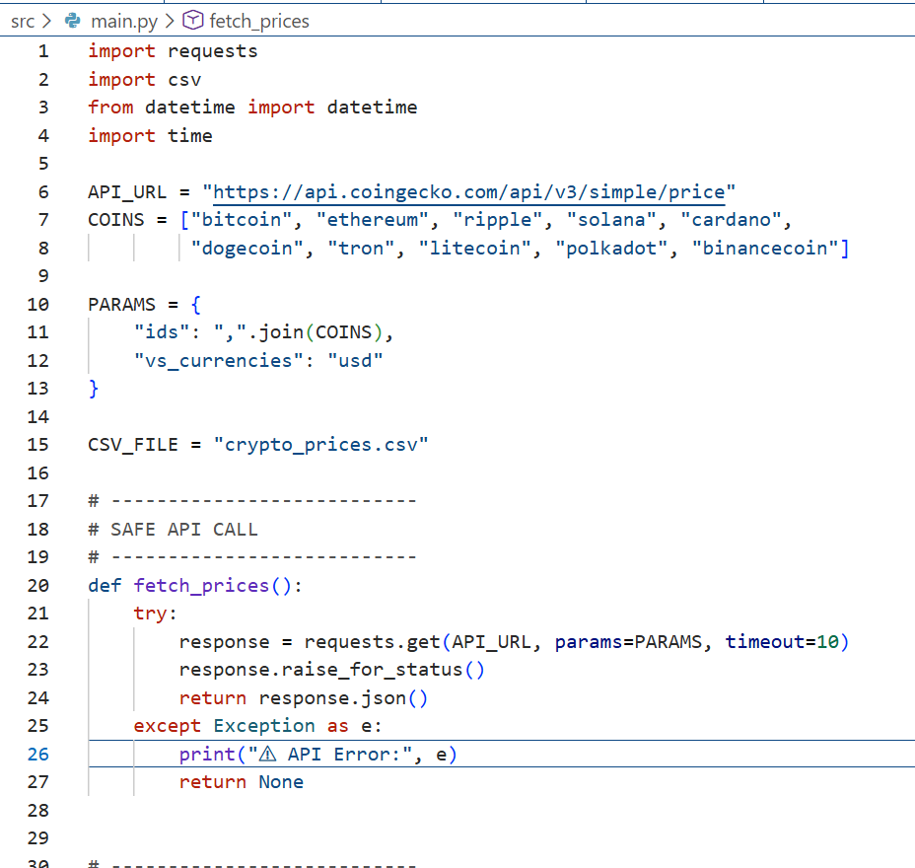
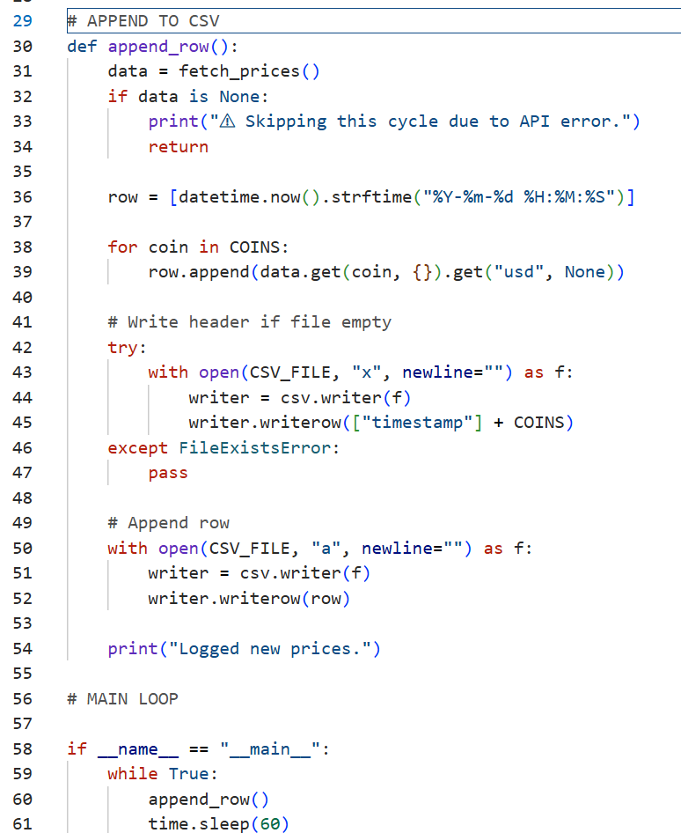

EXTRACTED COINS IN CSV
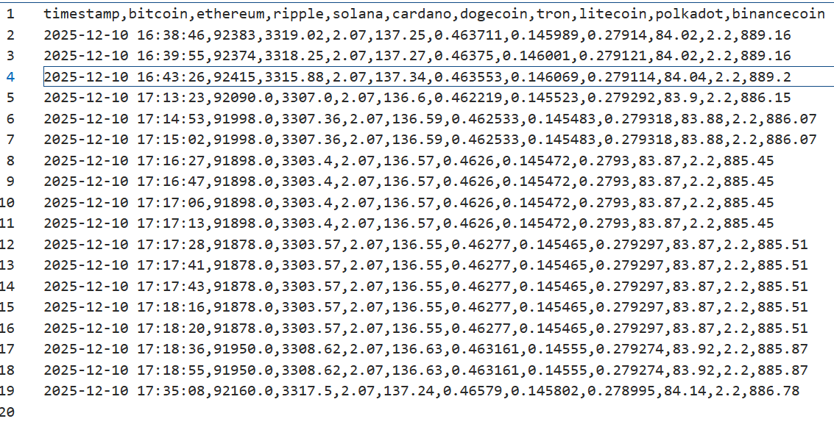
EXTRACTED COINS IN EXCEL
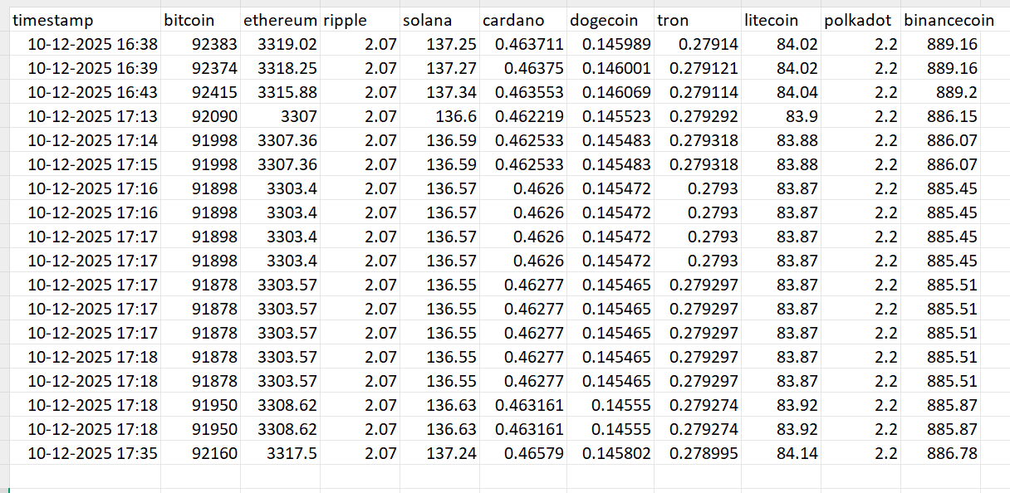

DASHBOARD:
Streamlit dashboad.py
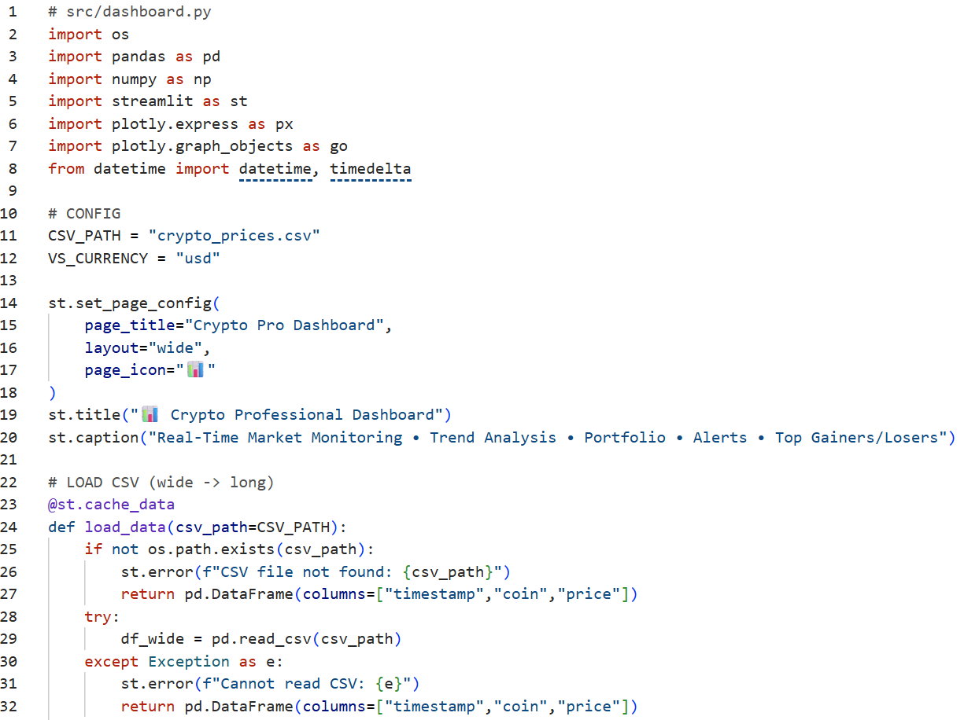
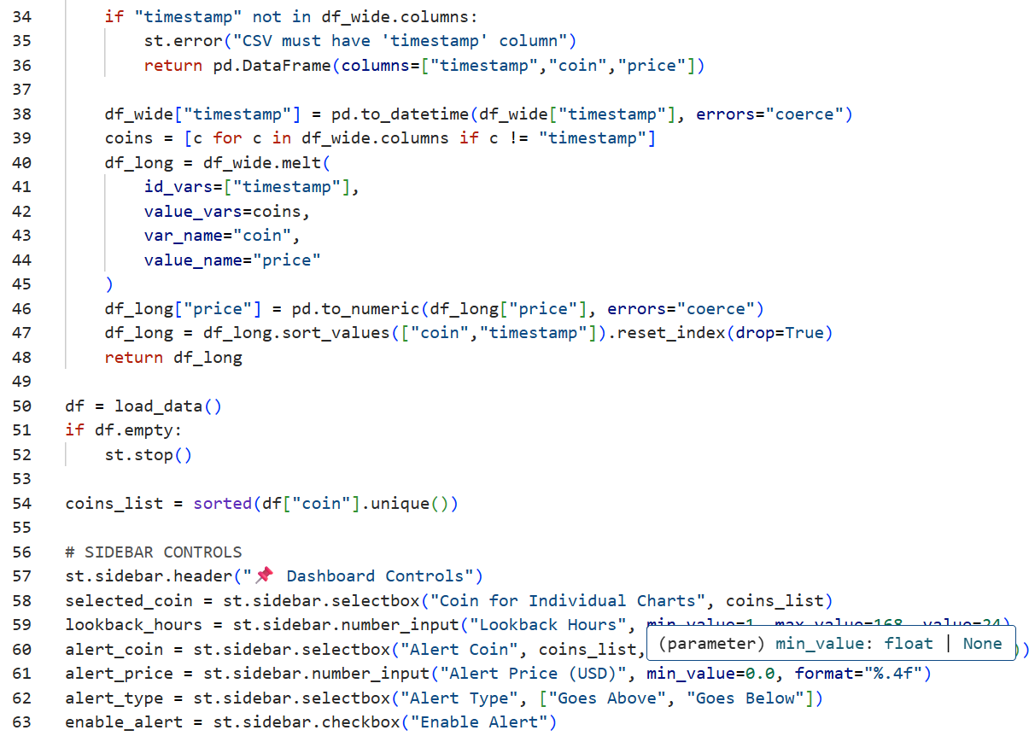
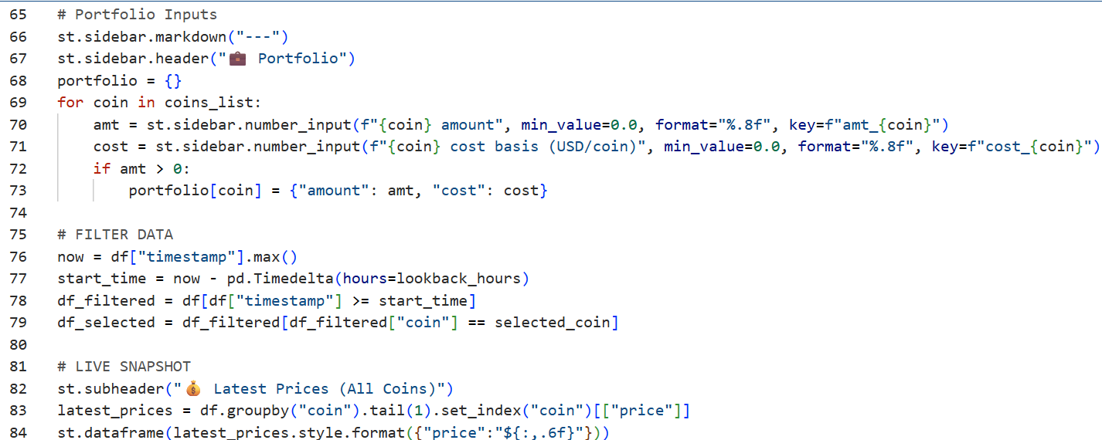
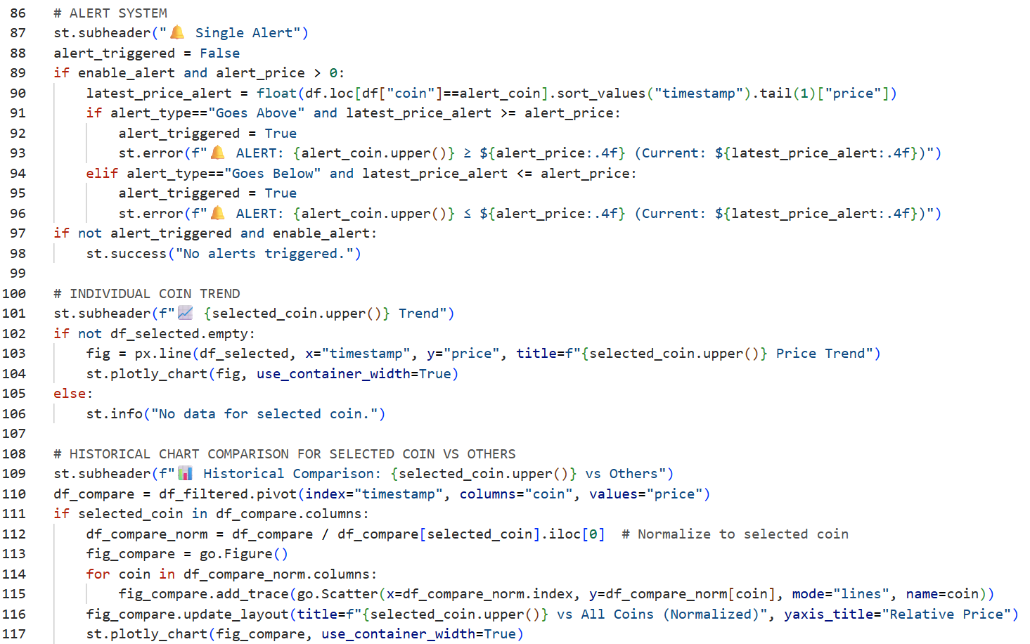
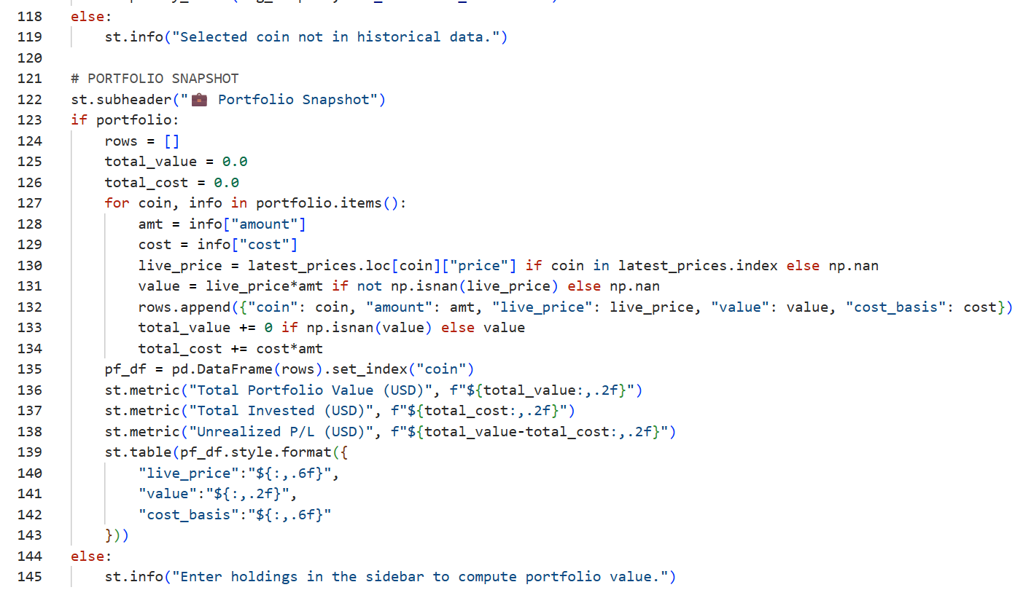
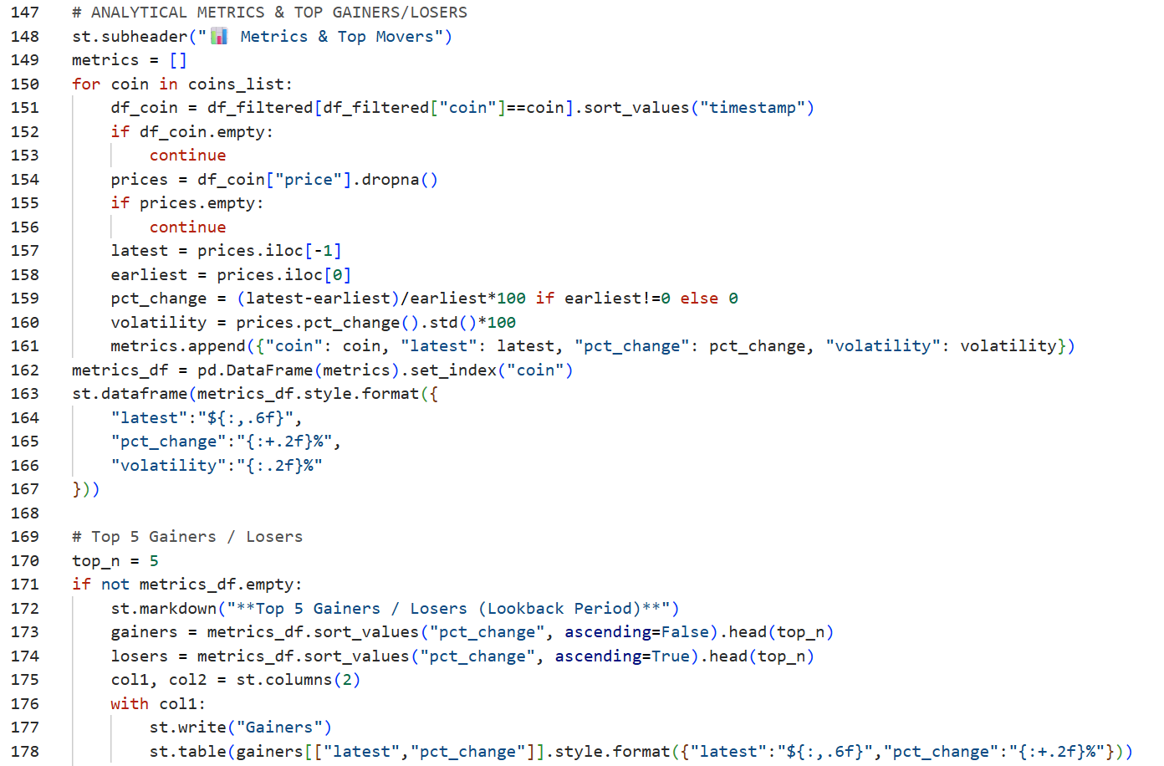
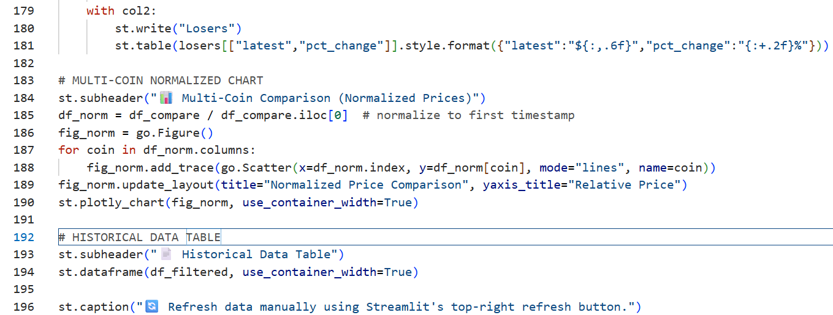

OUTCOME
REAL TIME MARKET MONITORING
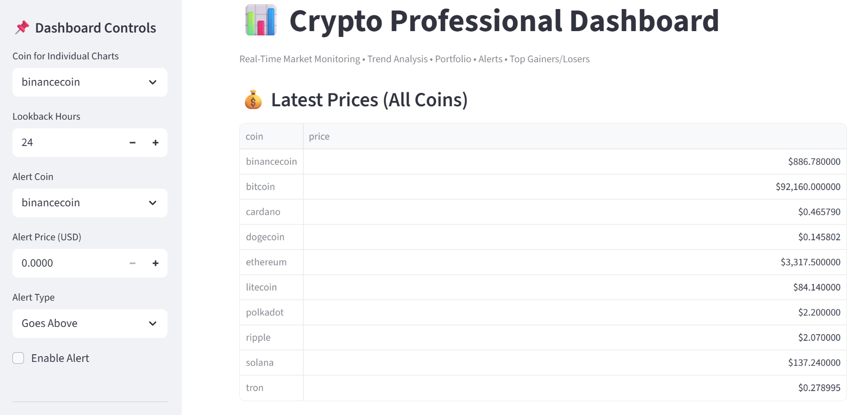

TREND ANALYSIS
For selected coin
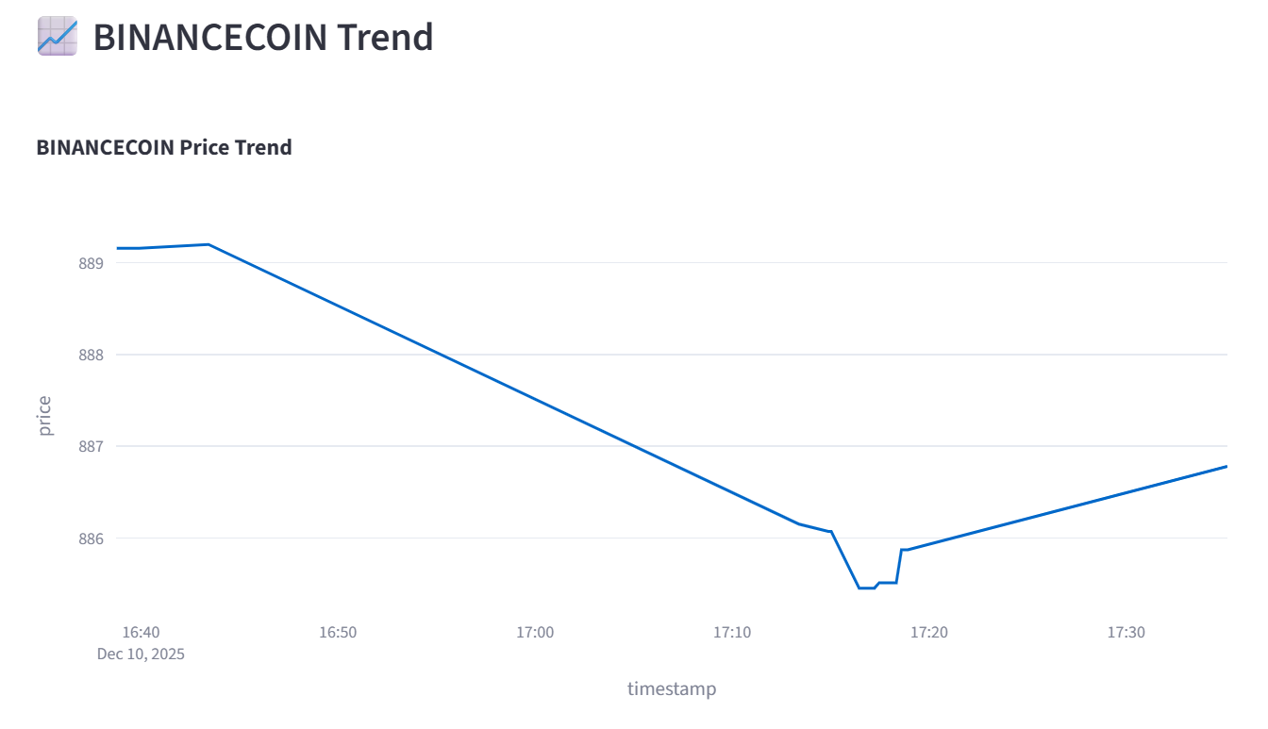
For multiple coin
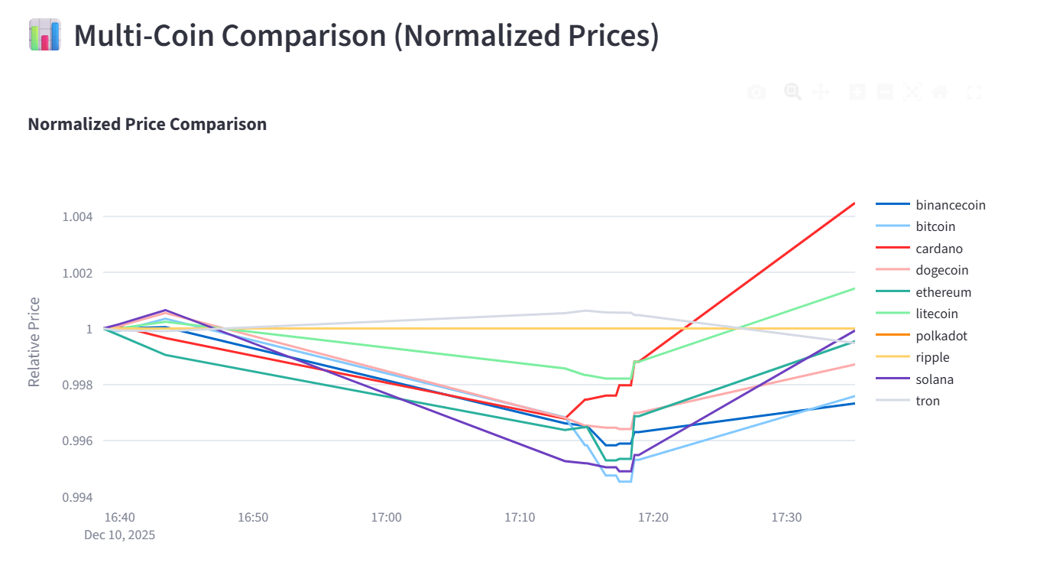
For selected coin vs others
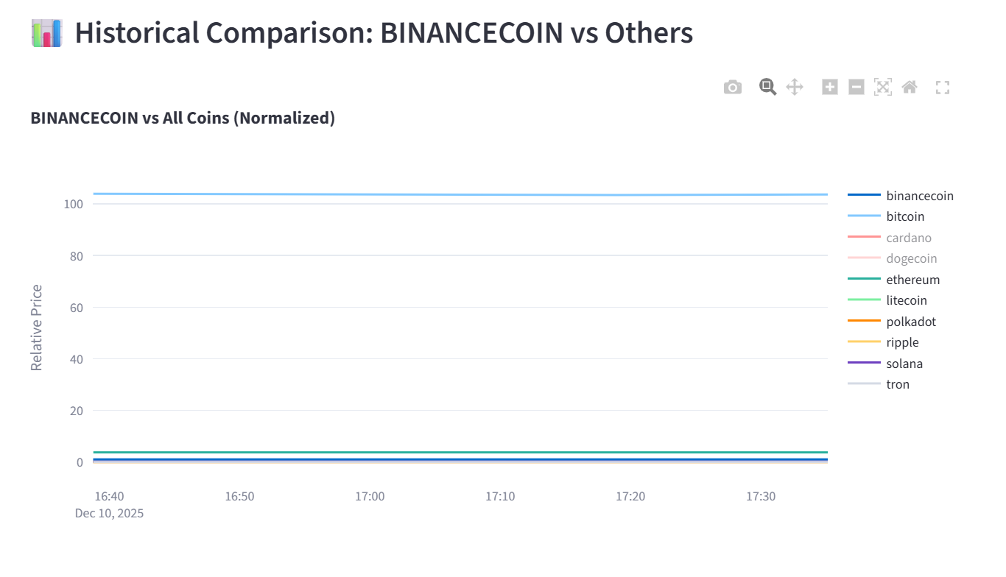
CUSTOM ALERT AND FILTERING LOGIC
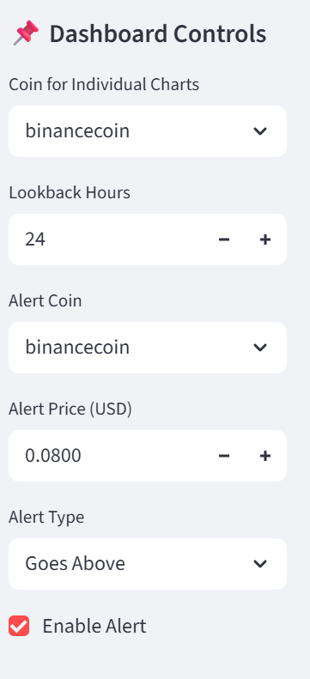
Alert system
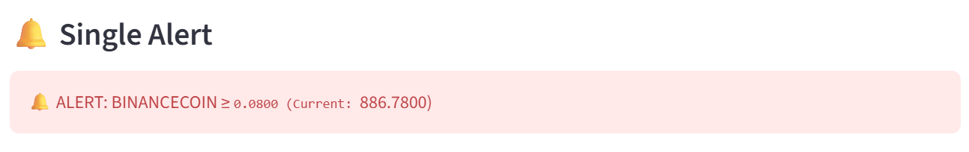
HISTORICAL DATA TABLE
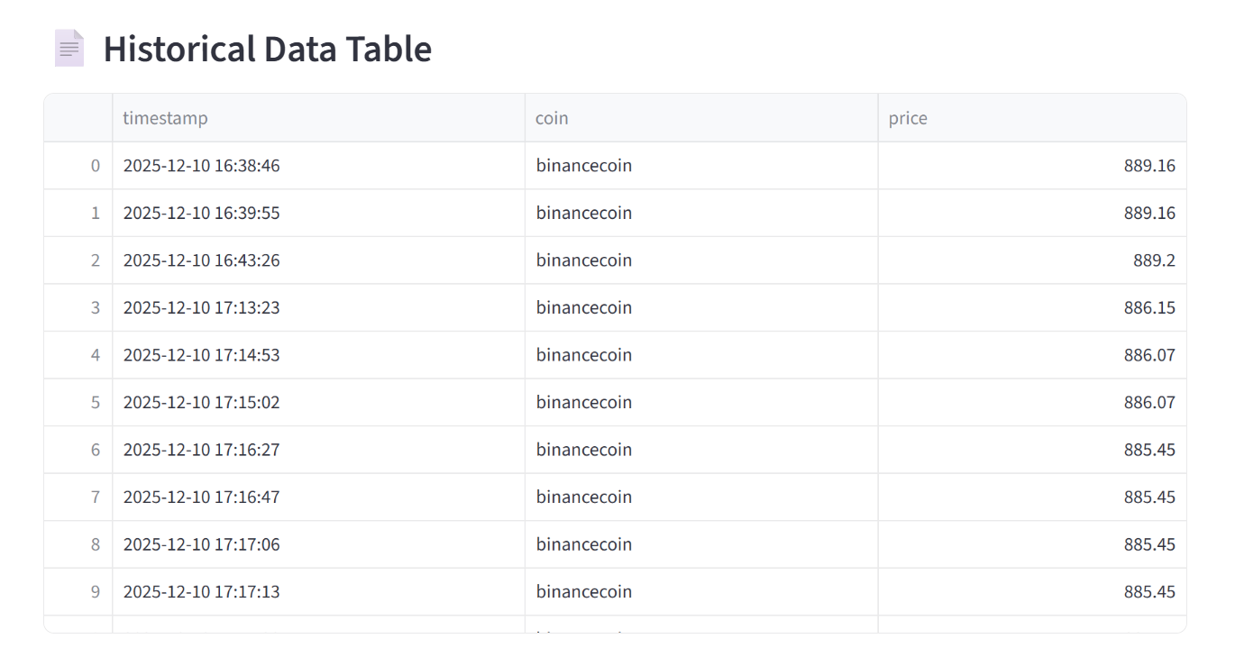
TOP 5 GAINERS AND LOSERS
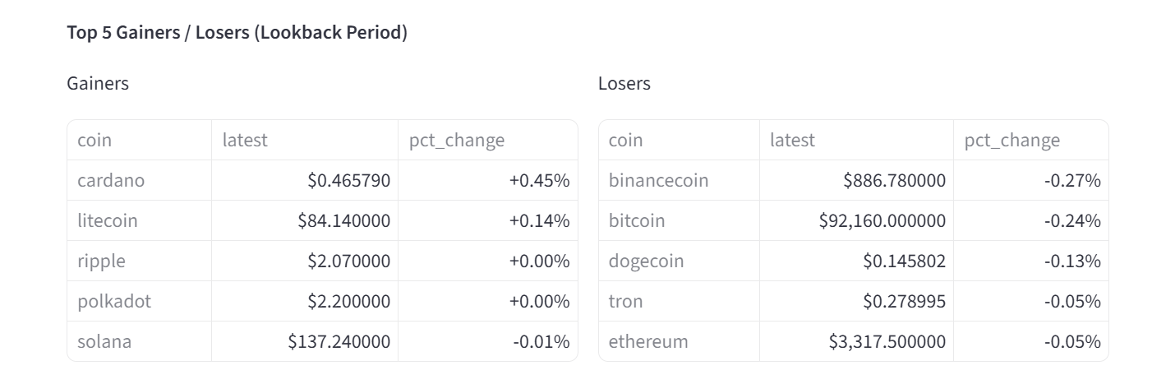
METRICS AND TOP MOVERS
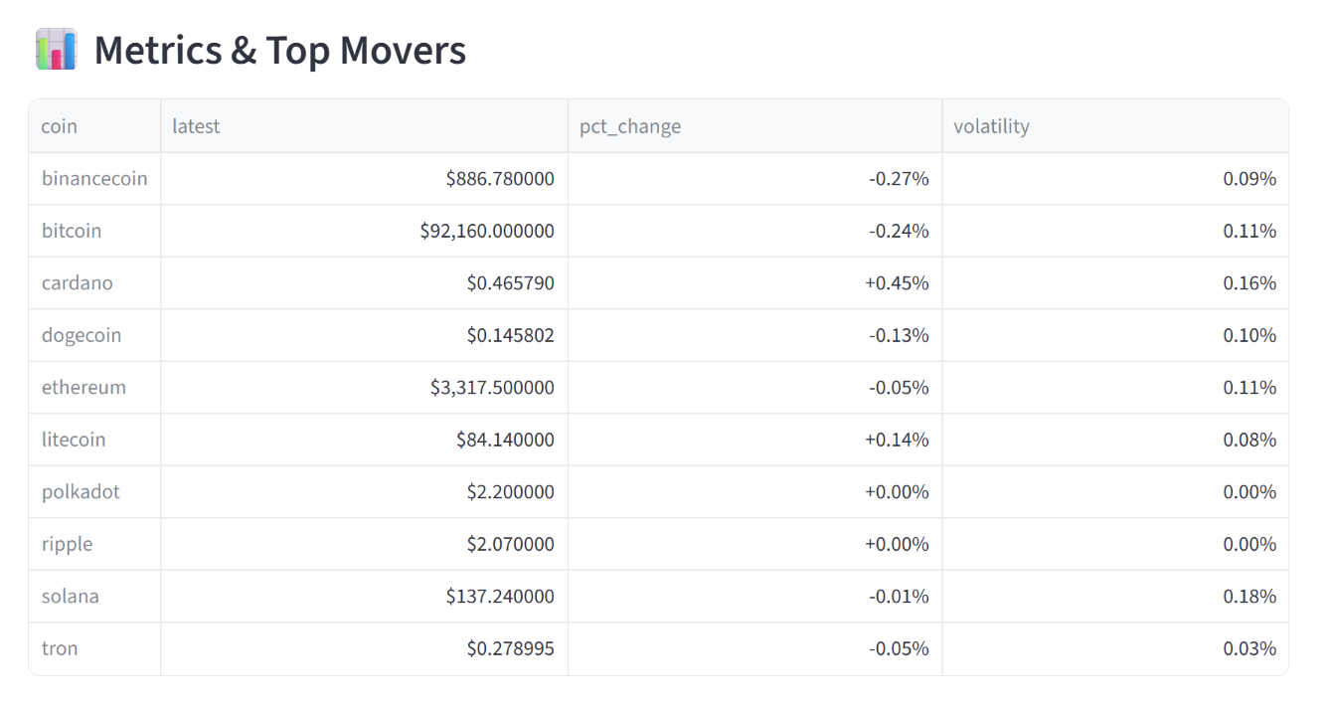
PORTFOLIO TRACKING
